Rodrigo Fernando Jiménez Dencker
Guillem Ramoneda Béjar

Style Guide

Description

We are GROD Hotel, a 5 star hotel company We are focused on all types of high class customers and we offer all kind of luxuries.

In our hotels frequent celebrities, including actors, musicians, football players and businessmen, however, we accept all kind of people, not only “the famous ones”.

All our suites dispose of different installations like Jacuzzis, ambiental lights, views of the city that cannot be seen anywhere else and other high luxury services such as massages from expert chiropractors, catering with the best wine selection, indoor pools, and much more.

We would love to give you your best experience ever and make you feel very comfortable in each of our hotels, so we invite you to come and have a good stay with us.

Level of Formality

We have a very high level of formality because we are a high class hotel and we would want to treat our customers as they deserve, with respect and formality.

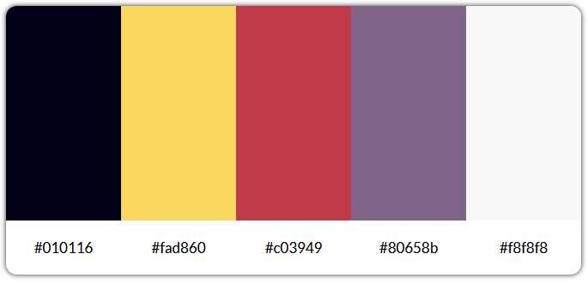
Colors

Primary colors are #010116 and #fad860 and they are used for some backgrounds and most of fonts.
Secondary colors are #80658b and #f8f8f8 and they are used as complementary colors, for some decorations and titles.
Tertiary color is #c03949 which is also used as a complementary color.

In some cases, these colors change slightly to another variation of itself:

#fad860 has the variation of #bb981a which is used when user hovers the links on our main navbar and also the links and social icons found on footer. It has also the variation of #f8e7ab, which basically it is the same color but with an opacity of 80%, it is used when user hovers form elements.

#c03949 changes to #a11a2a when the user hovers all links not listed before and to #6d0814 for visited links (darker color).

Finally, #f8f8f8 has a small darker variation, which is #e6e6e6 and a darker one, which is #ccc, both are used in checkboxes and radio inputs of our custom form, we use it to make the hover effects and to distinguish them from the background.

CSS Styles

- Our layout is composed of a header and a footer. The header contains the logo of our hotel, a banner of one of our hotels that fades with a gradient background and a nav that underlines when gets hovered using the id #main-nav.

- The footer has legal disclaimers of our hotels and some useful links, the copyright and golden icons in boxes that redirects you to the our social networks using the class .footer_icons.
When you hover the icons and the links, they get the same darker color.

- The background is made out of a golden pattern with the colors we have listed in this document before.

- Then, we show our different sizes of letters where the sizes h1 and h2 has different color (our from the rest of it.

- After that, we show our types of letters where we showcase links that change color when hovered, bold, cursive, quote and underlined examples.

- Afterwards, we have an example of a blockquote that is justified.

- Then we show a list with elements and subelements without their own style type because we want to keep them simple with the class .unordered_list.

- After that, we have an image of one of our rooms. We show the same image with different dimensions depending on our breakpoint set (which is 700px) and it has a figcaption and a cite in it with a link that redirects you to the page where the photo was taken.

- Afterwards, we have a table where the th are of our main color, the td are white and the text is centered using the class .custom_table.

- In the end, we have a basic form that lets the user input his username, password, zip code, email, url, textarea, select, file, date, checkbox and radio that when hovered it changes to our color, all of that in distinct classes like file, select and form.

CSS Styles - Mobile version

- We have one breakpoint, which is used to separate between laptop version and mobile version. The breakpoint is set at 700px.

- Width of .main_layout is set to 100%.

- #main_logo change its size to 130px to fit better with mobile layouts.

- Table headers are displayed next to the cell rows, at the left, we do it with the class .table_responsive.

- Our #main_nav is displayed and you will be able to see the hamburger menu.

- Content of .footer_container is displayed as a column.

- Width of form and class .file [input=[type”file”] is set to 70%, so it can fit better in mobile devices.

- Finally, all direct children divs inside .footer_container will be displayed to full width and the one that contains the copyright disclaimer will be displayed the last one.

Fonts

We use two different fonts, Julius Sans One, which is used for headers and links in our main navbar and Sulphur Point, which is our main font and it is used for all the other content.

- Julius Sans One - https://fonts.google.com/specimen/Julius+Sans+One

- Sulphur Point - https://fonts.google.com/specimen/Sulphur+Point

Icons

We use simple icons with no background from Flaticon because we think that they have one the best selection of icons (over 2 million of icons) and we can get them in many formats. Flaticon is free but it also has a premium version which includes more special icons, however, with free plan is more than enough for us.

We download our icons in SVG format and then we use IcoMoon to bring them all together in one SVG file. Then, we select the SVG listed inside of our main SVG.

Examples of the appearance of the icons:

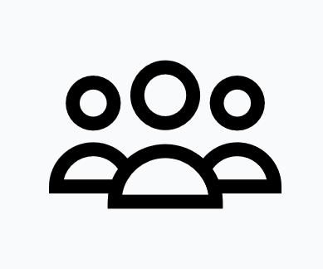
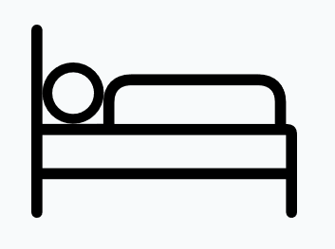

- Flaticon - https://www.flaticon.com
- IcoMoon - https://icomoon.io

